Week 9

13.Write a program to demonstrate predefined exceptions

14.Write a program to demonstrate user defined exceptions

15.Create a cursor, which displays all employee numbers and names from the EMP table.

Exceptions:-

An exception is an error condition during a program execution. PL/SQL supports programmers to catch such conditions using EXCEPTION block in the program and an appropriate action is taken against the error condition. There are two types of exceptions −
- System-defined exceptions
- User-defined exceptions

Syntax for Exception Handling
- The general syntax for exception handling is as follows. Here you can list down as many exceptions as you can handle. The default exception will be handled using WHEN others THEN
- DECLARE
- <declarations section>
- BEGIN
- <executable command(s)>
- EXCEPTION
- <exception handling goes here >
- WHEN exception1 THEN
- exception1-handling-statements
- WHEN exception2 THEN
- exception2-handling-statements
- WHEN exception3 THEN
- exception3-handling-statements
- ........
- WHEN others THEN
- exception3-handling-statements
- END;

Pre-defined exceptions are the errors that are already been defined by the oracle.

Oracle Corporation has several pre-defined exceptions like NO_DATA_FOUND, TOO_MANY_ROWS, etc. Each exception has a SQL Error Number and SQL Error Message associated with it.

- NO_DATA_FOUND: Raised when a select statement returns no rows.
- TOO_MANY_ ROWS: Raised when a select statement returns more than one row.
- VALUE_ERROR: Raised when the data type or data size is invalid.
- OTHERS: stands for all other exceptions not explicitly named in the exception handler.

Week 9:-

Step1:- create customer table

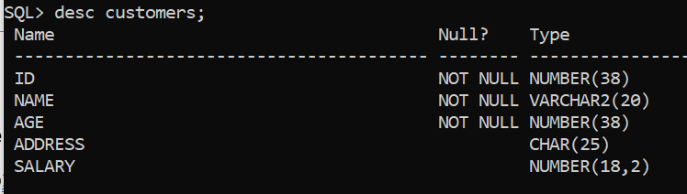

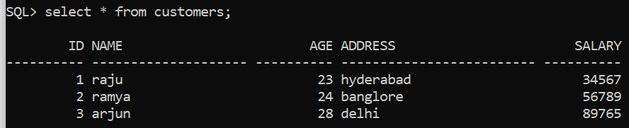

13) Write a program to demonstrate predefined exceptions.

declare

c_id customers.id%type:=8;

c_name customers.name%type;

c_addr customers.address%type;

Begin

select name, address into c_name,c_addr from customers where id=c_id;

dbms_output.put_line('Name:'||c_name);

dbms_output.put_line('Address:'||c_addr);

Exception

when no_data_found then

dbms_output.put_line('no such customer exist in the database!');

when others then

dbms_output.put_line('Error!');

end;

/

Output:-

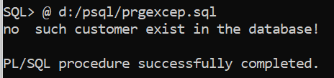

The above program displays the name and address of a customer whose ID is given. Since there is no customer with ID value 8 in our database, the program raises the run-time exception NO_DATA_FOUND, which is captured in the EXCEPTION block.

Note:- In the code change the value of customer id as =3

c_id customers.id%type:=3;

then output is:-

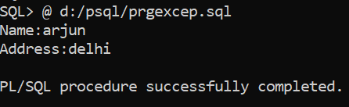

*********************************************************************

13)b)PL/SQL to illustrate predefined exceptions

declare

a number;

b number;

c number;

begin

a:=&a;

b:=&b;

c:=a/b;

dbms_output.put_line('division is '||c);

Exception

when Zero_Divide then

dbms_output.put_line('b could not be Zero');

end;

/

Output:-

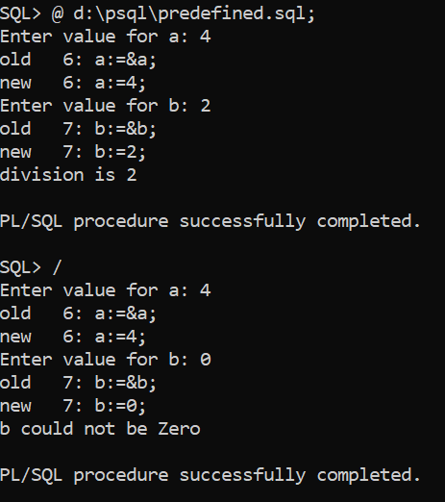

**************************************************************************************

User defined exceptions are the errors defined by the user to control the correct processing of data. Programmers have to raise user-defined exceptions explicitly. This can be done by using the RAISE command, with the syntax:

The syntax for declaring an exception is –

Eg:-

DECLARE

my-exception EXCEPTION;

RAISE <exception name>

Eg;_ RAISE my-exception

14)PL/SQL program to illustrate user defined exceptions:-

declare

c_id customers.id%type:=&c_id;

c_name customers.name%type;

c_addr customers.address%type;

--user defined exception

ex_invalid_id EXCEPTION;

begin

if c_id<=0 then

RAISE ex_invalid_id;

else

select name,address into c_name, c_addr from customers where id=c_id;

dbms_output.put_line(' Name:'||c_name);

dbms_output.put_line('Address:'||c_addr);

end if;

EXCEPTION

when ex_invalid_id then

dbms_output.put_line('ID must be greater than zero!');

when no_data_found then

dbms_output.put_line('No such customer!');

when others then

dbms_output.put_line('Error!');

end;

/

Output:-





